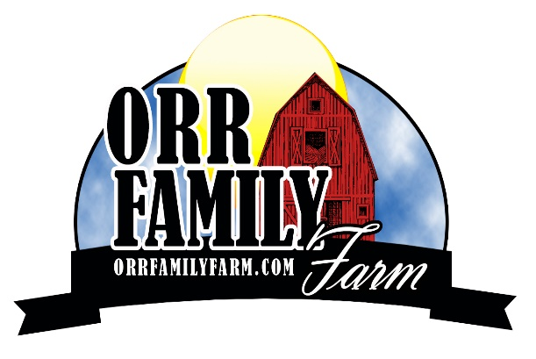
Orr Family Farm Employment Application
Applicant Information Full Name ____________________________________________________________________
Social Security Number _______________________________
Address ______________________________________________________________________
City _______________________________ State ____________________ Zip___________
Home Phone ______________________ Cell Phone ______________________
Email ______________________________________
If you are under age 18, provide your birthdate: Month: ______ Date: ________ Year: ______
Reliable Transportation: ______ own a car _____ friend/relative _____ other
Employment Desired Date Available to Start _____________________
Choose which shift (s) works best for you:
____ Monday through Thursday – Open to the public – 9:30 AM TO 5:30 PM – CLOSED TUESDAYS
Shifts available – 9 AM TO 5:30PM
____ Fridays and Saturdays – Open to the public - 10 AM TO 9PM - Shifts available -
____ 9 AM TO 5:30 PM ____ 9 AM TO 10 PM ____ 5 PM TO 10 PM
____ Sundays – Open to the public – 10 AM TO 6 PM - Shifts available 9 AM TO 6:30 PM
____ Zombie Blasters -Fridays and Saturdays - shift 6 PM TO 10PM
IMPORTANT: Indicate any schedule conflicts during the shift you are applying for.

Indicate any dates you will need off between the dates of September 24th – November 12th.

If you are a student, what shifts are you available to work on fall break?
____ Thursday, October 20, 2022 – Open to the public – Shifts available:
____ 9 AM TO 5:30 PM ____ 9 AM TO 10 PM ____ 5 PM TO 10 PM
____ Friday, October 21, 2022 – Open to the public – Shifts available:
____ 9 AM TO 5:30 PM ____ 9 AM TO 10 PM ____ 5 PM TO 10 PM

What type of position are you interested in? Please mark all that apply: __ Cashier __ Concession __Animal Barn Attendant __Attraction Attendant ___ Pony Ride Attendant __Zombie Attraction Actor __ Zombie Attraction Technician
The following positions require you that you be at least 21 years of age and have experience driving large equipment.
__Train Driver __ Tractor Driver

Tell us about YOU!
- Describe yourself in 3 words: _______________, _________________, ________________
- Have you ever been to the Orr Family Farm as a customer? Yes ____ No ____
Describe your experience. (If no, describe a similar attraction, you have experienced)

- How would our business benefit by hiring you? What strengths would you bring to our business?

- Tell us about your hobbies, activities you participate in or how you spend your free time?

- Employment History: If this is your first job, on the reverse side, list your high school, grade you attend and any experience that would make you a valuable employee (volunteer work, leadership in organizations, excelling in a favorite subject).

Previous Employment (Begin with the most recent position):
Dates of Employment: From____________________________ To _______________________ Position(s) Held ________________________________________________________________
Firm _________________________________________________________________________
Address ______________________________________________________________________
Phone ________________________________________________________________________ Supervisor _________________________________________ Title ______________________ Responsibilities ________________________________________________________________
Reason for Leaving _____________________________________________________________
May we contact this employer as a reference? ______________________________________

Previous Employment:
Dates of Employment: From____________________________ To _______________________
Position(s) Held ________________________________________________________________
Firm _________________________________________________________________________
Address ______________________________________________________________________
Phone ________________________________________________________________________ Supervisor _________________________________________ Title ______________________ Responsibilities ________________________________________________________________
Reason for Leaving _____________________________________________________________
May we contact this employer as a reference? ______________________________________

Answering “yes” to these questions does not constitute an automatic rejection for employment.
Date of the offense, seriousness and nature of the violation, rehabilitation, and position applied for will be considered. There are positions that require the successful candidate to have a valid driver’s license. The successful candidate would have to provide proof that s/he has a valid driver’s license when offered employment.
Have you ever worked for the Orr Family Farm? Yes____ No____ If yes, when? _________________________________________________________________________
Are you a citizen of the United States? Yes____ No____ If not, are you legally allowed to work in the United States and can you provide documentation? Yes____ No____ Have you ever been convicted of a crime? You must answer yes to this question for every conviction unless the record of the criminal charge has been sealed or expunged. Yes____ No____ If yes, give dates and details:_____________________________________________________________ _____________________________________________________________________________________ _____________________________________________________________________________________

I certify that my answers are true and complete to the best of my knowledge. I authorize you to conduct a criminal background check and investigations into my personal, employment, educational and other related matters as may be necessary for employment at the Orr Family Farm. I agree to a drug test prior to or during my employment. I hereby release employers, schools, or individuals from all liability when responding to inquiries in connection with my application. In the event I am employed, I understand that false or misleading information given in my application or interview(s) may result in discharge. Signature of Applicant _______________________________________ Date ___________________ ____________________________________________________________________________________ Please return your completed application to our Farm office at 14200 S. Western in Oklahoma City, fax it to (405) 799-7794, via e-mail to info@orrfamilyfarm.com or mail to the address below: Orr Family Farm 14200 S. Western Oklahoma City, Oklahoma 73170

FALL SEASON DATES
SEPT. 24TH & 25TH 10 AM – 6 PM
SEPT 24TH – NOV 12TH FALL SEASON
SEPT HOURS SATURDAYS & SUNDAYS 10 AM – 6 PM
OCT HOURS MON – THURS 10 AM – 5 PM Oct. 7 – 31st closed Tuesdays
FRI/SAT 10 AM – 9 PM SUN 10 AM – 6 PM
NOV 5th 10 AM – 5 PM
NOV 12th 10 AM – 5 PM
OCT 1st – OCT 29TH ZOMBIE PAINTBALL
OCT HOURS FRI & SAT dark to 10:00 PM
“OCTOBER SPECIAL HOURS”
FALL BREAK OCT 20TH 10 AM - 9 PM (Thursday)
HALLOWEEN OCT. 31ST 10 AM – 4 PM
NOV 2 & 3rd FIELD TRIP MAKE UPS
NOV 5TH & 12TH FALL FINALE – OPEN 10 AM TO 5 PM

